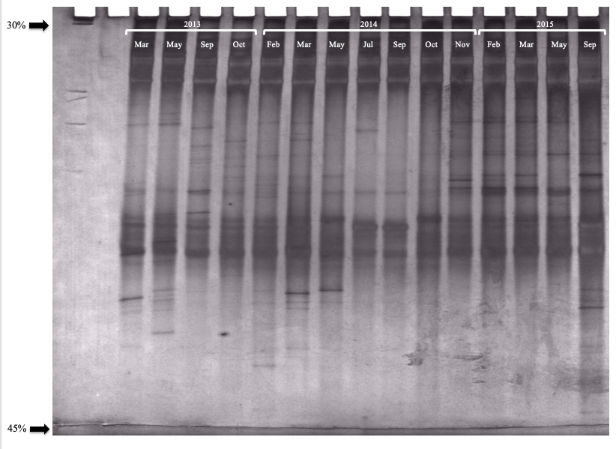

Figure 1S. DGGE profiles obtained from the bacterial amplicons of the V6-V8 region purified with the PCR-DGGE technique. Acrylamide gel electrophoresis. The gradient was 30-45 %. Samples were obtained from the Bordo Poniente Composting Plant (BPCP, West Rim Composting Plant) in Mexico City.

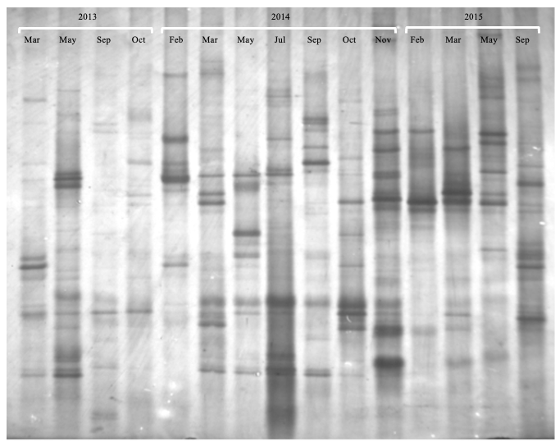
Figure 2S. DGGE profiles obtained from the fungal amplicons of the ITS1 region purified with the PCR-DGGE technique. Acrylamide gel electrophoresis. The gradient was 30-55 %. Samples were obtained from the Bordo Poniente Composting Plant (BPCP, West Rim Composting Plant) in Mexico City.

